# **Experimental Analysis**

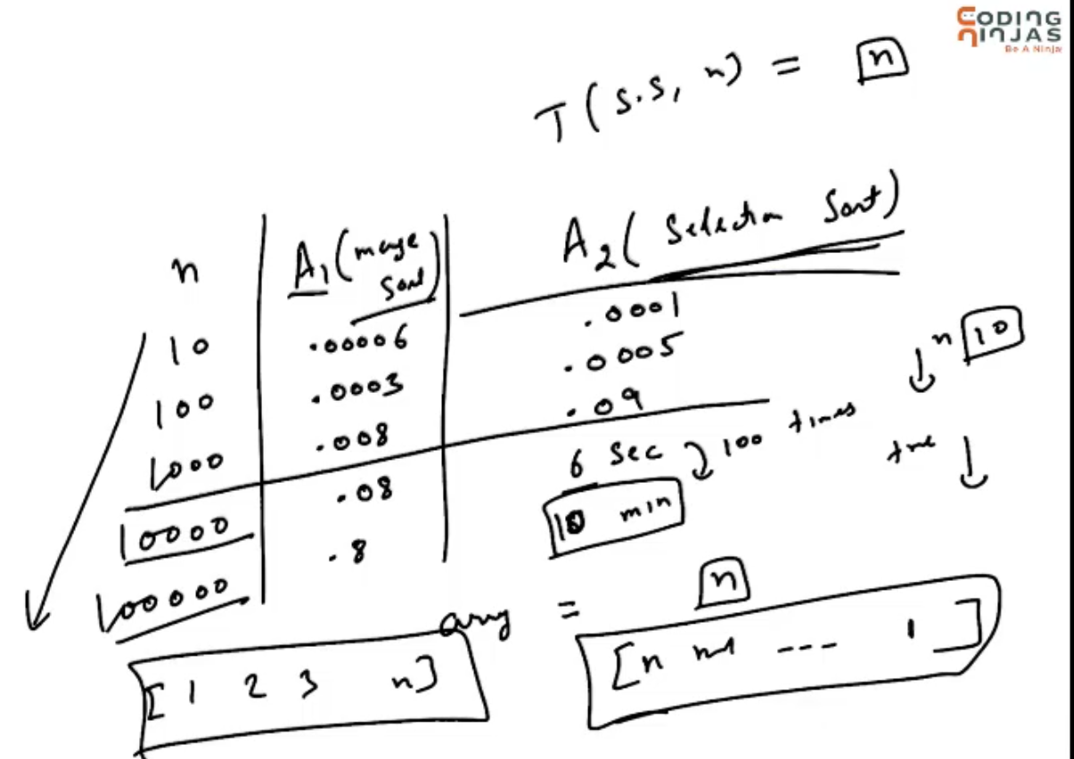

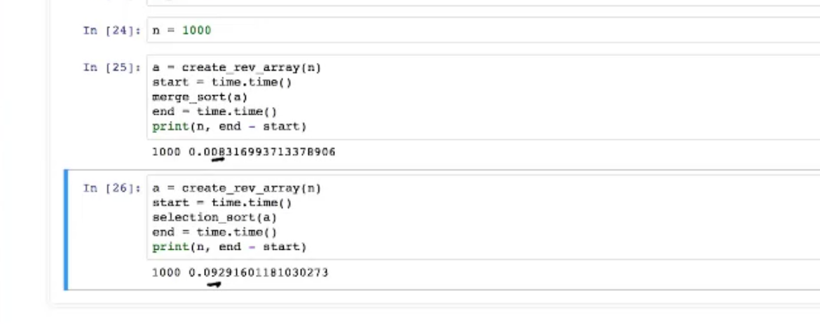

This time depends upon the environment the code is running.  
This time is not only the algorithm taking time, algorithm + overall system time also.

# **Theoretical Analysis**

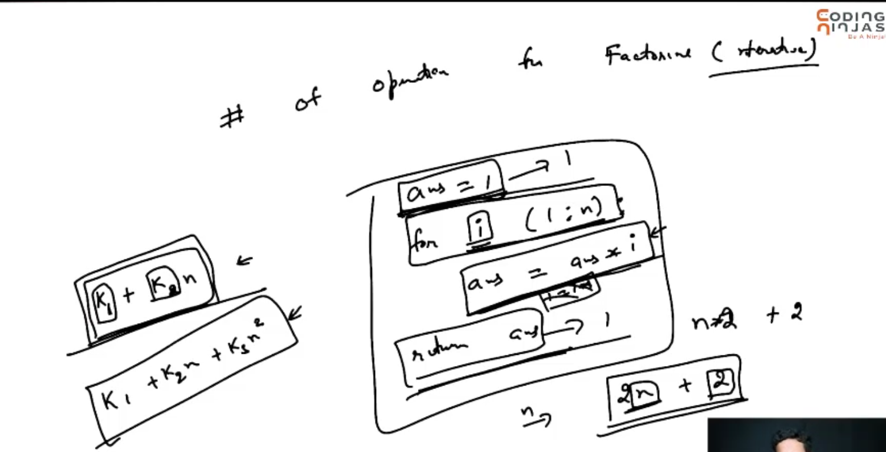



Algorithm 🡪 factorial of a number using recursion.

Finding the structure of these functions(linear/quadratic) are important. Rather than finding what is K1 and K2.

# **Big-Oh Notation**

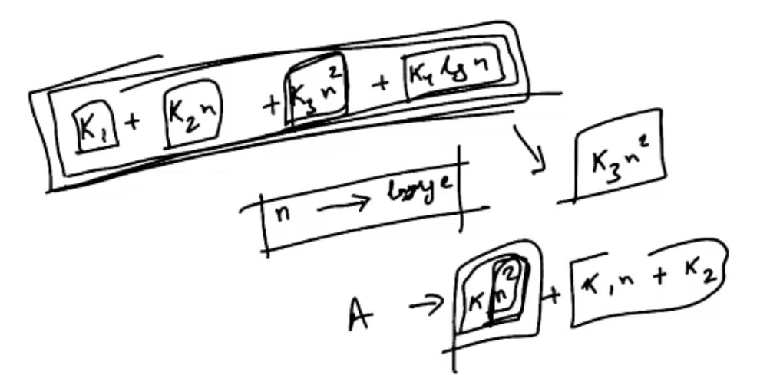

Among all the polynomials n^2 🡪 increases rapidly as n increases.

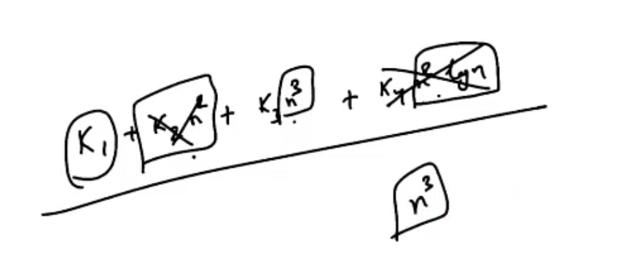

Among all the polynomials n^3 🡪 increases rapidly as n increases.

